**P**rojec**t** 🡪 **P**rogram **M**anagemen**t**: **P**roject Manage**r** 🡪 **R**ober**t** **P**incu**s**

**W**orkflo**w** 🡪 **W**aveCrest **F**ee **I**mplementation – **T**EX**T**/**D**iagra**m**

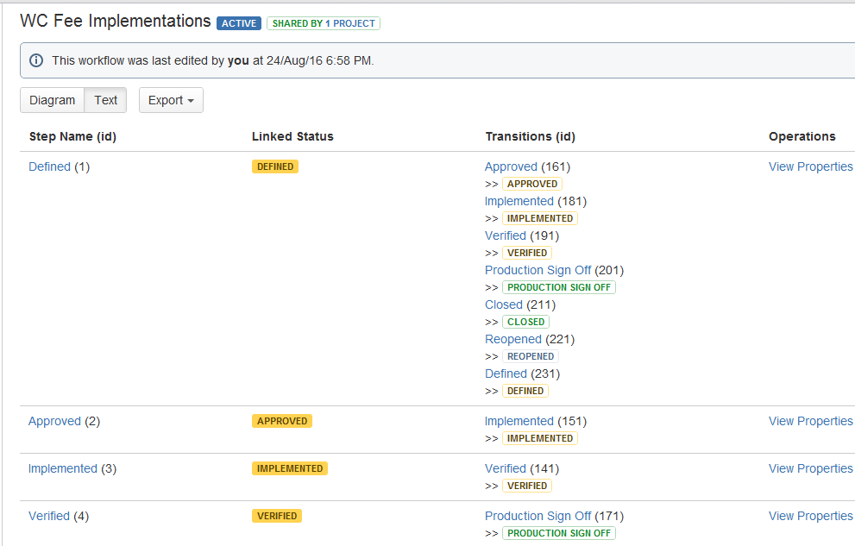

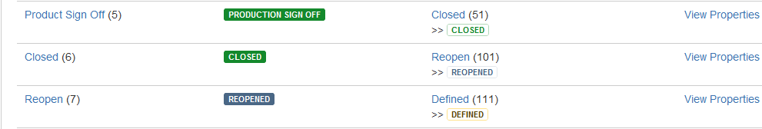

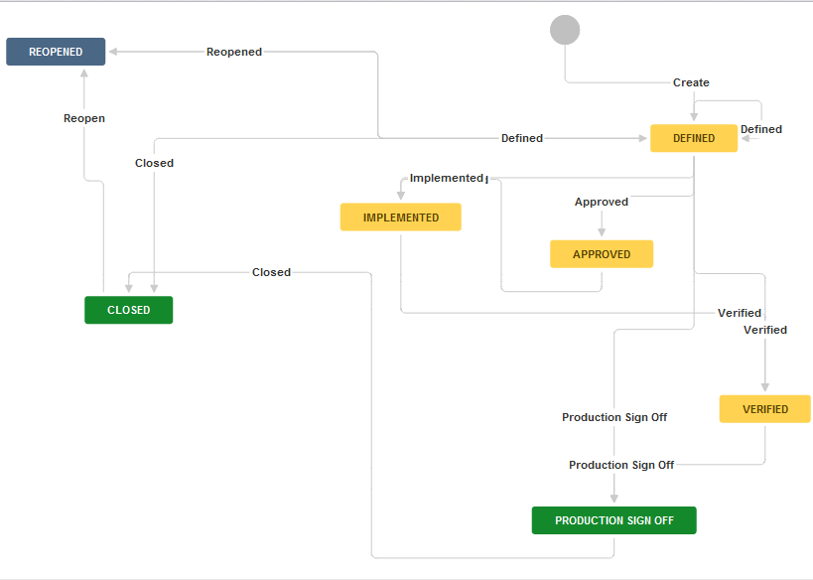

1. **D**efine**d** 🡪 **A**pprove**d**
2. **A**pprove**d** 🡪 **I**mplemente**d**
3. **I**mplemente**d** 🡪 **V**erifie**d**
4. **V**erifie**d** 🡪 **P**roduction Sign of**f**
5. **P**roduction Sign of**f** 🡪 **C**lose**d**
6. **C**lose**d** 🡪 **R**eope**n**
7. **R**eope**n** 🡪 **D**efine**d**